**Final Report**



**PES UNIVERSITY**

**(Established under Karnataka Act No. 16 of 2013)**

**100-ft Ring Road, Bengaluru – 560 085, Karnataka, India**

***Dissertation on***

**‘Title of the project’**

***Submitted by***

**SIDDHANT DUTTA (01FB15EME138)**

**VISHNU KULKARNI (01FB15EME160)**

**VRUSHABH SINGH THAKUR (01FB15EME161)**

**Jan. - Apr. 201**

**under the guidance of**

***External Guide Internal Guide***

**Dr. / Prof. XXXXX Prof. RAJENDRA PRASAD**

**Designation Designation**

**Affiliation Department of _________**

**PES University**

**Bengaluru -560085**



**FACULTY OF ENGINEERING**

**DEPARTMENT OF MECHANICAL ENGINEERING**

**PROGRAM: B.TECH – MECHANICAL ENGINEERING**

**CERTIFICATE**

*This is to certify that the Dissertation entitled*

**‘Title of the project’**

*is a bonafide work carried out by*

**SIDDHANT DUTTA (01FB15EME138)**

**VISHNU KULKARNI (01FB15EME160)**

**VRUSHABH SINGH THAKUR (01FB15EME161)**

In partial fulfillment for the completion of 8th semester course work in the Program of Study **B.Tech in** **Mechanical Engineering** under rules and regulations of PES University, Bengaluru during the period **January – April 2019**. It is certified that all corrections/suggestions indicated for internal assessment have been incorporated in the report. The dissertation has been approved as it satisfies the 8th semester academic requirements in respect of project work.

*Signature with date & Seal Signature with date & Seal Signature with date & Seal*

*Internal Guide Chairperson Dean of Faculty*

|  |  |  |  |
| --- | --- | --- | --- |
| Signature of Examiners during Viva – Voce (End Semester Assessment) | | | |
| Sl. No. | Name | Affiliation | Signature |
|  |  |  |  |
|  |  |  |  |
|  |  |  |  |

**DECLARATION**

We, **Student Name 1, Student Name 2** and **Student Name** **3**, hereby declare that the dissertation entitled, ‘***Title of the work’,*** is an original work done by us under the guidance of **Dr./Prof./Mr./Ms. xxx**, Designation, Affiliation, and is being submitted in partial fulfillment of the requirements for completion of 8th Semester course work in the Program of Study **B.Tech in** **Mechanical Engineering**.

**PLACE:**

**DATE:**

|  |  |  |  |
| --- | --- | --- | --- |
| **Name and Signature of the Candidates** | | | |
| Sl. No. | Name | SRN | Signature |
|  | SIDDHANT DUTTA | 01FB15EME138 |  |
|  | VISHNU KULKARNI | 01FB15EME160 |  |
|  | VRUSHABH SINGH THAKUR | 01FB15EME161 |  |

**Acknowledgement**

**Table of Contents**

**ABSTRACT**

**List of Table**

**List of Figures**

**Nomenclature**

**Literature Review**

1. **Printed Circuit Heat Exchangers**

1.1 Introduction

1.2 Construction

1.3 PCHE Features & Capabilities

1.4 Applications

**2. Super-Critical Fluids**

2.1 Introduction

2.2 Significance of Specific Heat (Cp)

**3.2D Analysis of a microchannel**

3.1 Introduction

3.2 Meshing

3.3 Fluent Details

3.4 Graphs

3.5 Formulae

3.6 Calculation Table

3.7 Discussion

**4.3D Analysis of a Double Pipe Heat Exchanger**

4.1 Introduction

4.2 Meshing

4.3 Fluent Details

4.4 Graphs

4.4.1 Temperature Variation

4.4.2 Specific Heat Variation

4.4.3 Specific heat variation keeping both the velocities variable

4.4.4 Thermal Conductivity Variation

4.4.5 Thermal Conductivity Variation keeping both the velocities variable

4.4.6 Temperature Contour

4.4.7 Temperature Contour for variable velocities

4.5 Formulae

4.6 Calculation Table

4.7 Discussion

**ABSTRACT**

Printed Circuit Heat Exchangers (PCHE) are compact in size which consumes less ground space, frames and associated equipment resulting in less structural cost. PCHE are highly efficient which makes it a promising heat exchanger satisfying the requirements of supercritical fluids vaporization at low and high pressure.

Super-critical Carbon-dioxide is used as a working fluid. SCO₂ is taken into consideration as it is easily available in highest purity concentration, non-toxic, non - flammable and chemically inert. The super-critical temperature and pressure of carbon dioxide is 304.12K and 74 bar.

Throughout this project, various parameters are studied using FLUENT in ANSYS. Computational Fluid Dynamics (CFD) Analysis is carried out to determine Heat Transfer and pressure drop characteristics of SCO₂ in micro-channels of PCHE. Physical parameters such as thermal conductivity, specific heat, dynamic viscosities with respect to temperature is taken into consideration to run the simulations and graph for the same can be obtained. The final results are compared to the values available in the literature.

**List of Figures**

**Figure no Title Page**

Fig 1.1 Microchannels of PCHE

Fig 2.1 PV Diagram of Super Critical Carbon dioxide

Fig 2.2 Variation of Specific Heat (Cp) with Temperature and Pressure

Fig 3.1 Geometry of the 2D micro channel

Fig 3.2 Meshing of the 2D micro channel

Fig 3.3 Variation of Static Temperature vertically at x=0.1m

Fig 3.4 Variation of Velocity magnitude vertically at x=0.1m

Fig 3.5 Variation of Static Temperature vertically at x=0.3m

Fig 3.6 Variation of Static Temperature vertically at x=0.3m

Fig 3.7 Static Temperature Contour of the 2D microchannel

Fig 3.8 Static Temperature Contour of the 2D microchannel (magnified)

Fig 3.9 Static Temperature Contour of the 2D microchannel

Fig 3.10 Static Temperature Contour of the 2D microchannel (magnified)

Fig 4.1 Meshing of the 2D micro channel

Fig 4.2 Temperature Variation of along the pipe at v=0.053 m/s

Fig 4.2 Temperature Variation of along the pipe at v=0.707 m/s

Fig 4.2 Temperature Variation of along the pipe at v=0.8841 m/s

Fig 4.2 Specific Heat Variation of along the pipe at v=0.053 m/s

Fig 4.2 Specific Heat Variation of along the pipe at v=0.707 m/s

Fig 4.2 Specific Heat Variation of along the pipe at v=0.8841 m/s

Fig 4.2 Specific Heat Variation of along the pipe at variable velocities (1)

Fig 4.2 Specific Heat Variation of along the pipe at variable velocities (2)

Fig 4.2 Specific Heat Variation of along the pipe at variable velocities (3)

Fig 4.2 Thermal Conductivity Variation along the pipe at v=0.053 m/s

Fig 4.2 Thermal Conductivity Variation along the pipe at v=0.707 m/s

Fig 4.2 Thermal Conductivity Variation along the pipe at v=0.8841 m/s

Fig 4.2 Thermal Conductivity Variation along the pipe at variable velocities (1)

Fig 4.2 Thermal Conductivity Variation along the pipe at variable velocities (2)

Fig 4.2 Thermal Conductivity Variation along the pipe at variable velocities (3)

Fig 4.2 Temperature Contour of the Double Pipe

Fig 4.2 Temperature Contour for variable velocities of the Double Pipe

**List of Tables**

**Table no Title Page**

1 Calculation Table Of 2D analysis of a microchannel

2 Calculation Table Of 3D analysis of Double Pipe Heat Exchanger

**NOMENCLATURE**

a Aspect ratio

A Amplitude, mm

C Indices

D 2 x major axis, mm

dh Hydraulic diameter

d Diameter ,mm

f Fanning friction factor

gx, gy ,g z Acceleration due to gravity in x, y ,z direction,m/s2

h Heat transfer coefficient ,w/m2-k

K Thermal conductivity ,w/m-k

L0 Length of the duct, mm

2L Wavelength,mm

m Mass flow rate, kg/s

Nu Nusselt number

P Pressure,N/m2

Re Reynolds Number

Pr Prandtl Number

T Temperature ,K

Vx Vy Vz Velocity in x,y,z direction/s

w m Area weighted average velocity

**Geek Symbols**

∆P Pressure drop

µ Viscosity , pa-s

ρ Density of fluid,kg/m3

**Subscripts**

b bulk

h hydraulic

f mean

w wall

x,y,z Direction

**Abbreviations**

PCHE Printed Circuit Heat Exchanger

**Literature Review**

**Satya Prakash Kar (2007)** has studied a compact heat exchanger in the form of micro-channels of semi-circular cross-section. Due to geometrical constraints semi-elliptical cross-section is being used and PCHE for different conditions of temperature and pressure at constant heat flux is designed. Different boundary conditions are taken into consideration and parameters such as heat transfer and pressure drop characteristics are calculated for a fully developed laminar flow in straight duct. The variation is studied using FLUENT analysis. Thermal conductivity, specific heat, dynamic viscosities, Reynold’s number and aspect ratio with respect to temperature is taken into consideration to run the simulations and graph for the same can be obtained.

**Zhongzao Zhai** **and et.al., (2017)** has chosen PCHE as it is highly efficient in satisfying the heat exchange requirements of supercritical fluid vaporization at low and high pressure. They have chosen Liquified Natural Gas as the working fluid and the inlet temperature and pressure being 121k and 10.5 MPa respectively. The numerical investigation was done using FLUENT in ANSYS for airfoil fin, straight channels and staggered channels.

**Yang Chen and et al.** discusses the heat exchangers used for supercritical carbon dioxide refrigeration process including a suction gas heat exchanger in the cycle.

The supercritical carbon dioxide’s thermophysical properties will have sharp variations in the region close to its critical point. This variation has a significant influence on the shape of the heat exchanger’s temperature profile and the heat transfer performance of the heat exchanger.

**Computational Fluid Dynamics**

Due to availability of high performance computing hardwares and introduction of new CFD softwares, it has become convenient to carry out CFD Analysis. Earlier one had to write a code to carry out the simulations.

1. **Printed Circuit Heat Exchangers**

**1.1 Introduction**

The Printed Circuit Heat Exchanger is a compact heat exchanger which was established in the University of Sydney in the 1980s. A manufacturer company known as Heatric was formed in Australia in the year 1985 with a goal to commercialise the concept. Its first application was in industrial refrigeration systems. After Heatric’s move to UK in 1989, PCHEs have gained acceptance worldwide in offshore industry. There are over 500 PCHEs that are working in the world currently.

**1.2 Construction**

The core of PCHE is constructed by chemically milling flow pessages and stacking and diffusion bonding the plates into a single block. If necessary, multiple diffusion bonded blocks maybe welded together to form larger units, before headers and nozzles are welded on to complete the exchanger. Diffusion Bonding process is solid state welding process to joint similar and dissimilar metals. It promotes grain growth across metal boundary resulting in a joint exhibiting parent metal strength and ductility. The diameter of the microchannels is 1-2mm.In this model, Supercritical Carbon dioxide is used as a working fluid. SCO₂ and water are passed through the alternate microchannels in opposite direction resulting in a counter flow.

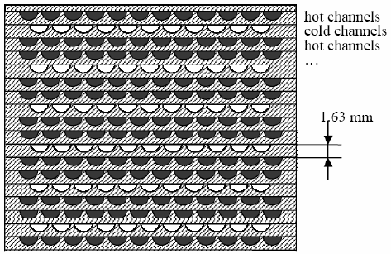

Fig 1.1 Microchannels of PCHE

**1.3 PCHE Features & Capabilities**

**High Pressures**

PCHE cores can withstand high pressures. PCHEs with design pressures of 500 bar are being used.

**Extreme Temperatures**

The materials such as austenitic stainless steel allow temperatures from cryogenic to 900°C (1650°F).

**Enhanced Safety**

PCHEs are not prone to hazards that are associated with shell and tube exchangers, such as flow induced tube vibration and tube rupture. Overpressure relief systems can thus be reduced to a significant extent. PCHEs are highly compact which also indicates that they have relatively low inventory as compared to shell and tube exchangers.

**Close Approach Temperatures**

Fluid contact can be counter flow, cross flow, or a combination of these two flows. Counter current design enables deep temperature crosses and temperature approaches of 3-5°C.

**High Effectiveness**

PCHEs have high thermal effectiveness in excess of 97% in a single compact unit. High effectiveness heat exchangers can reduce the duty, size and expenditure

**1.4 Applications**

**Hydrocarbon gas & NGL Processing**

**Gas processing**

Liquids recovery

LNG & cryogenic

Synthetic fuels production

**Chemicals processing**

Acids- nitric, phosphoric etc.

Alkalis - caustic soda, caustic potash

Fertilizers - ammonia, urea

**Refining**

Reactor feed/effluent exchangers

Air separation

**Power & Energy**

Chillers & condensers

Cascade condensers

Absorption cycles

Geothermal generation

Nuclear applications

Major oil companies such as Cheveron, BP, Shell, ExxonMobil, etc., and operators such as SBM, MODEC, etc., are using PCHEs for projects all over the world.

1. **Super-Critical Fluids**

**2.1 Introduction**

When a fluid is subjected to temperature and pressures higher than its critical point, then the fluid is said to be supercritical. In this stage the fluid attains the properties intermediate to that of liquids and gases. The supercritical fluids possess densities like that of a liquid, viscosities like that of gases and diffusivities intermediate to that of liquid and gas. It is the most widely used supercritical fluid. The critical temperature and pressure for Carbon dioxide are 304.12 K and 7.4 MPa respectively. At this temperature and pressure, it adopts the properties midway between liquid and gas. Super-critical Carbon dioxide is non-flammable, chemically inert, non-toxic and low cost making it a suitable Super-Critical Fluid. SCO₂ finds its applications in power generations, manufactured products, decaffeination, cleaning processes.

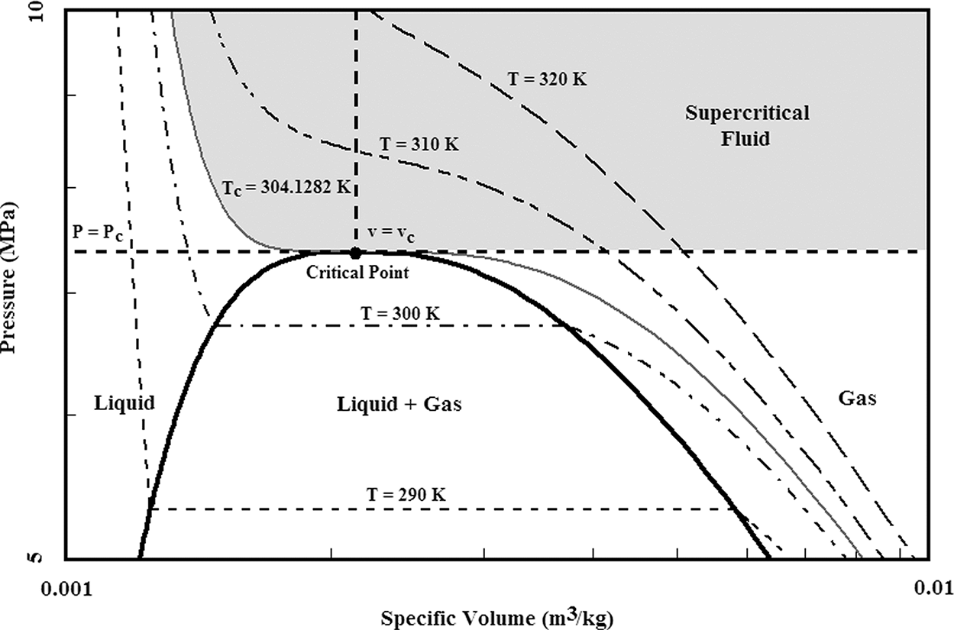

Fig 2.1 PV Diagram of Super Critical Carbon dioxide

**2.2 Significance of Specific Heat (Cp)**

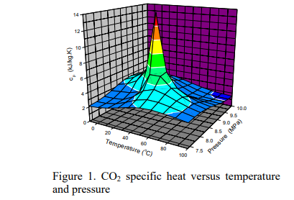

Fig 2.2 Variation of Specific Heat (Cp) with Temperature and Pressure

This is a 3D overview of the variation of specific heat of CO2 with temperature and pressure in Supercritical region. It can be seen that at each supercritical pressure, the value of Cp changes drastically as the temperature rises and reaches its maximum at a certain temperature. The point at which the Cp reaches its peak is called the pseudocritical temperature for a given pressure. The higher the pressure is, the larger the pseudocritical temperature is. With the increasing pressure, the peak of Cp decreases.

The primary reason for the usage of CO2 in the heat exchangers is because of the great change in thermophysical properties in the supercritical region. There is an exchange of momentum and energy in the direction kof heat flux. When the pseudocritical temperature is between the wall temperatutre and the fluid temperature, the properties along the cross section vary greatly and this results in the good heat exchange performance.

**2D ANALYSIS of a microchannel**

**3.1 INTRODUCTION**

As per our methodology, a 2D model of a microchannel is created in FLUENT with length 400 mm and diameter 4mm.The 2D surface has rectangular cross section and the extremities are named as inlet, outlet and walls. The working fluid is taken as air. The flow of working fluid is assumed to be steady, laminar and incompressible throughout the analysis. The inlet velocity and Operating Pressure is u=0.2m/s and 101325 Pa respectively

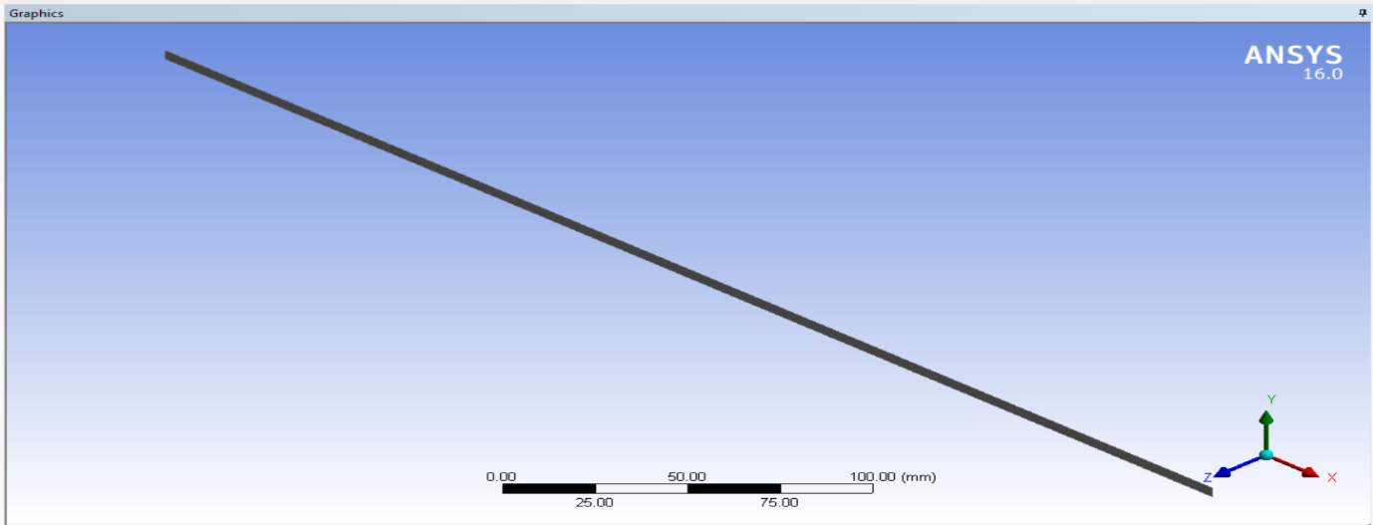

Fig 3.1 Geometry of the 2D micro channel

**3.2 Meshing**

A fine mesh is generated on the surface of the 2D model using Fluent.The mesh generated in this rectangular surface consists of 12,480 elements and the orthogonal quality is 5.7146 e-01.

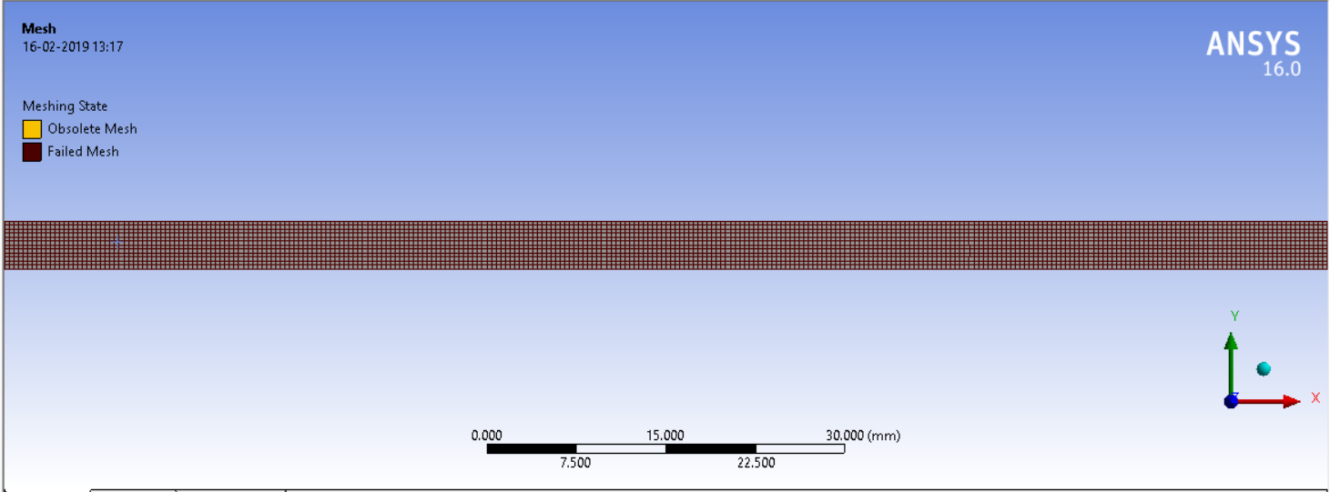

Fig 3.2 Meshing of the 2D micro channel

**3.3 Fluent Details**

The flow is steady, laminar and compressible.

2D axis-symmetry geometry is created.

Meshing is finer near the wall.

Simple Solver is used.

Material Properties: Air (default)

Operating Pressure: 101325 Pa.

Wall constant Heat Flux: 100w/m2

Pressure-Velocity Coupling: SIMPLE

**3.4** **Graphs**

**At x=0.1m**

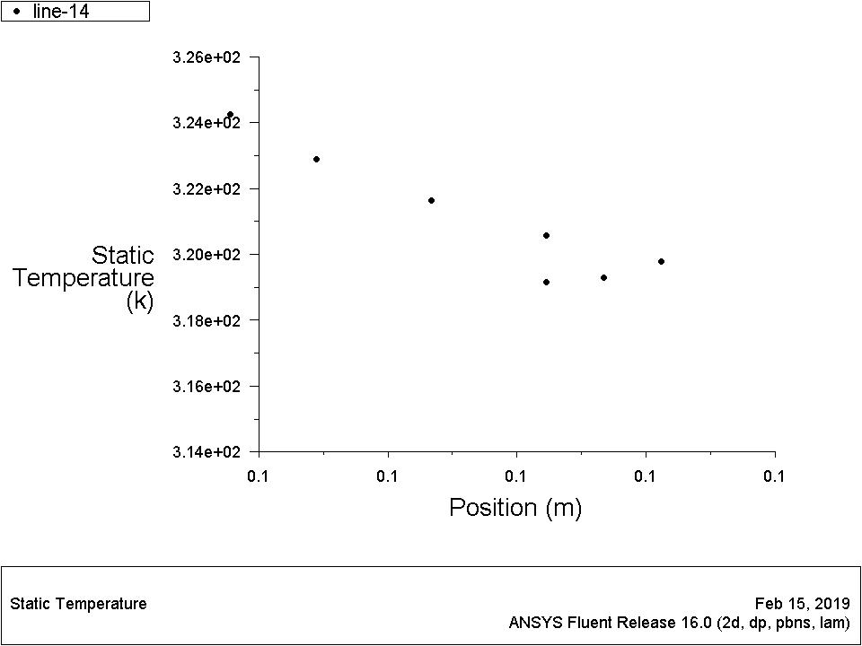

Fig 3.3 Variation of Static Temperature vertically at x=0.1m

The plots are carried out. At x=0.1m, the flow is developing and laminar. As the flow propagates, the static temperature decreases from the walls towards the center and also along the length. The temperatures at different points at x=0.1 is Facet averaged to get the fluid temperature.

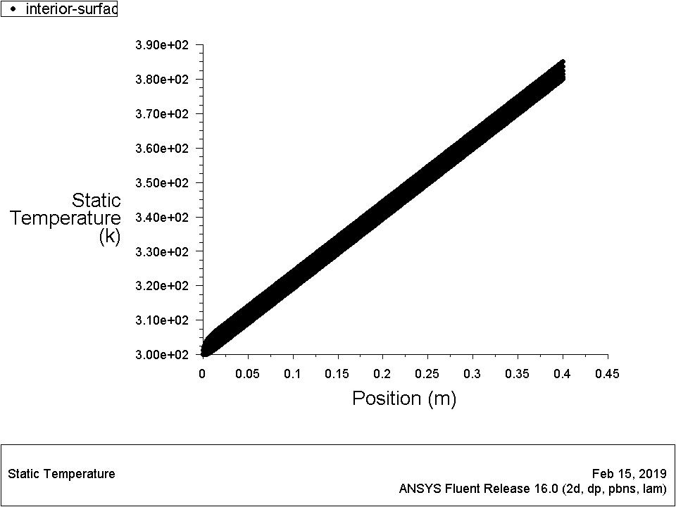

The static temperature varies linearly as the flow proceeds. At x=0.1mm, the temperature of both the top and bottom walls is noted. The temperature at both the walls is averaged to get the wall temperature.

**At x=0.3mm**

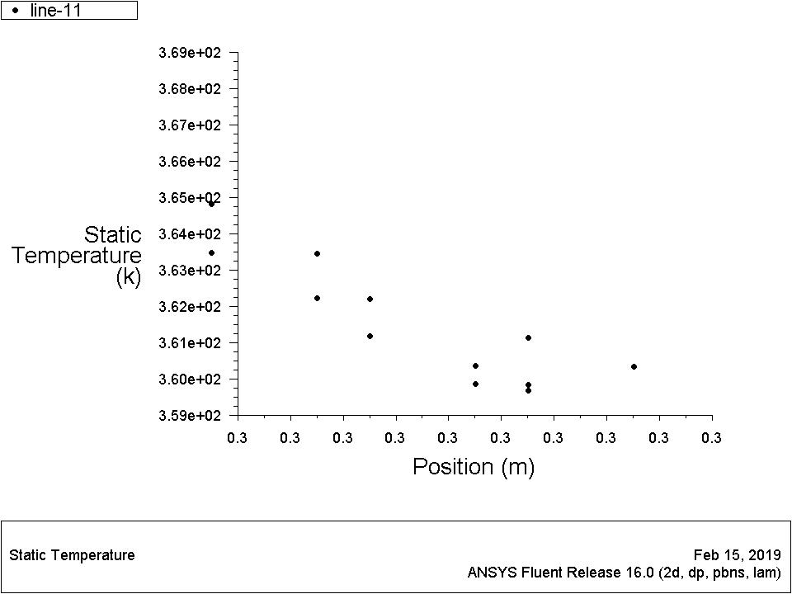

Fig 3.5 Variation of Static Temperature vertically at x=0.3m

At x=0.3mm, the flow is fully developed and laminar. As the flow propagates, the static temperature decreases from the walls towards the center. The temperatures at different points at x=0.3mm is Facet averaged to get the fluid temperature.

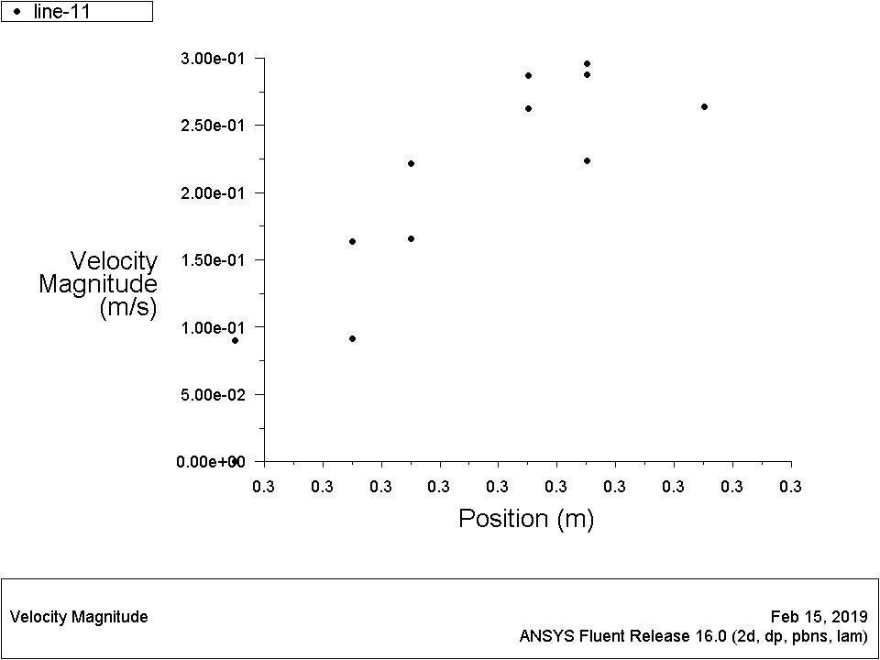

Fig 3.6 Variation of Velocity magnitude vertically at x=0.3m

At x=0.3mm, the flow is fully developed and laminar. As the flow propagates, the velocity increases from the walls towards the center.

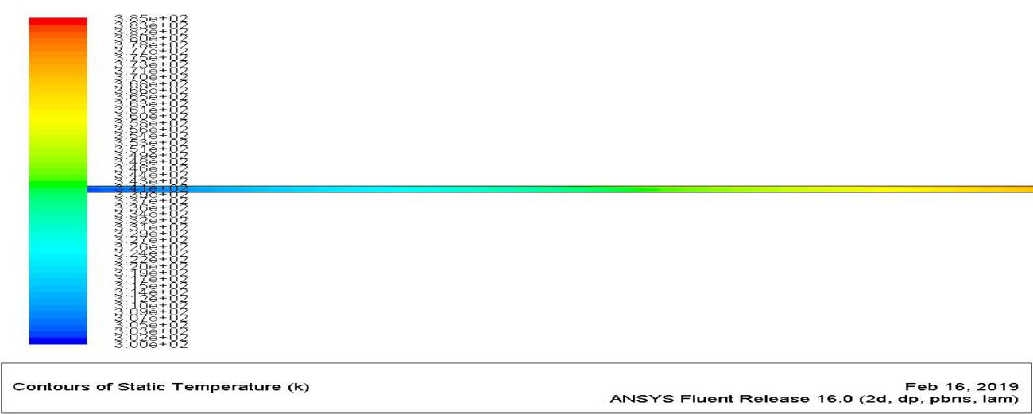

Fig 3.7 Static Temperature Contour of the 2D microchannel

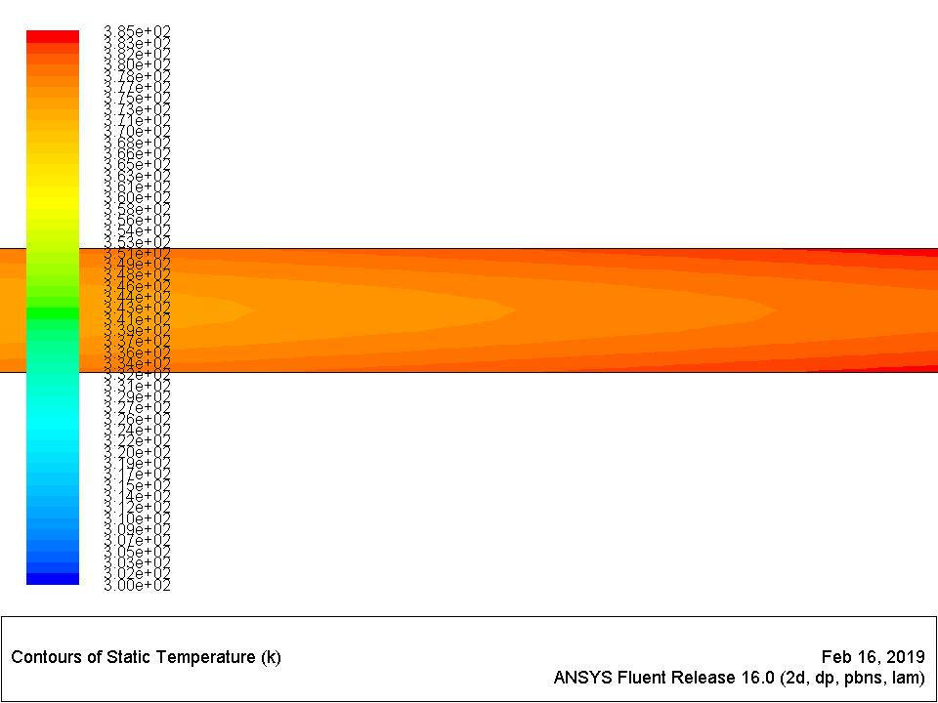

Fig 3.8 Static Temperature Contour of the 2D microchannel (magnified)

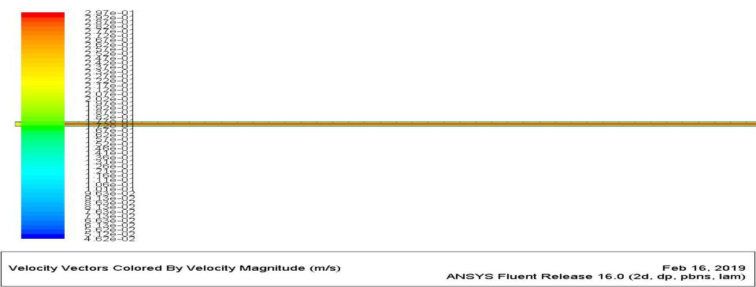

Fig 3.9 Velocity Contour of the 2D microchannel

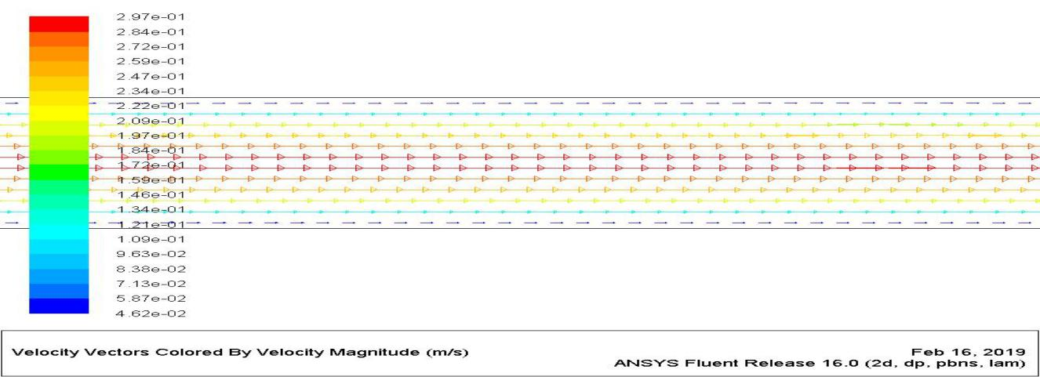

Fig 3.10 Velocity Contour of the 2D microchannel (magnified)

**Formulae**

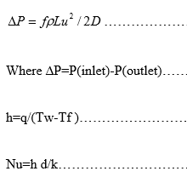

**Calculation Table**

|  |  |  |  |  |  |  |  |
| --- | --- | --- | --- | --- | --- | --- | --- |
| Section | Tw(k) | Tf(k) | Tw-tf | h | Nu | f |  |
| X=0.1mm | 325 | 321.1 | 3.9 | 25.64 | 4.23 | 1.3 |  |
|  |  |  |  |  |  |  |  |

**3D Analysis of a Double Pipe Heat Exchanger**

**4.1 Introduction**

A detailed 3D model of a double pipe is created.The length of the pipe is 250 mm.The inner and outer diameter are 5mm and 10 mm respectively. SCO2 and water passes through the inner pipe and outer pipe respectively in counterflow direction.The boundary conditions provided are velocity and heat flux which are 0.53 m/s and 1000 W/m^2 respectively. SCO2 is used as working fluid. Carbon-dioxide behaves as a super critical fluid at a temperature of 304K and 8 MPa.

**4.2 Meshing**

The geometry is meshed in Fluent.The inlet and outlet faces are linked so equal meshing is obtained. All the edges and faces are quad meshed. The number of elements obtained after meshing is

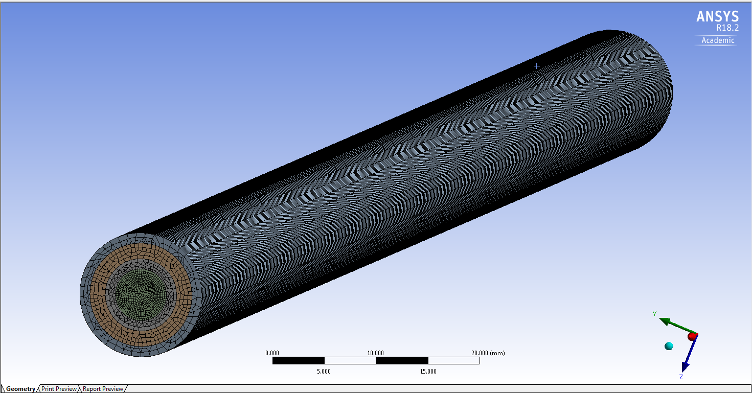

Fig 4.1 Meshing of the 2D micro channel

**4.3 Fluent Details**

The flow is steady, laminar and compressible.

3D geometry is created.

Meshing is finer near the wall.

Simple Solver is used.

Material Properties: Air (default)

Operating Pressure: 101325 Pa.

Wall constant Heat Flux: 100w/m2

Pressure-Velocity Coupling: SIMPLE

**4.4 Graphs**

**4.4.1 Temperature Variation**

A linear temperature variation is observed along length. An imaginary line is drawn parallel to the axis, along which the other thermophysical properties are calculated.

**At v=0.053 m/s**

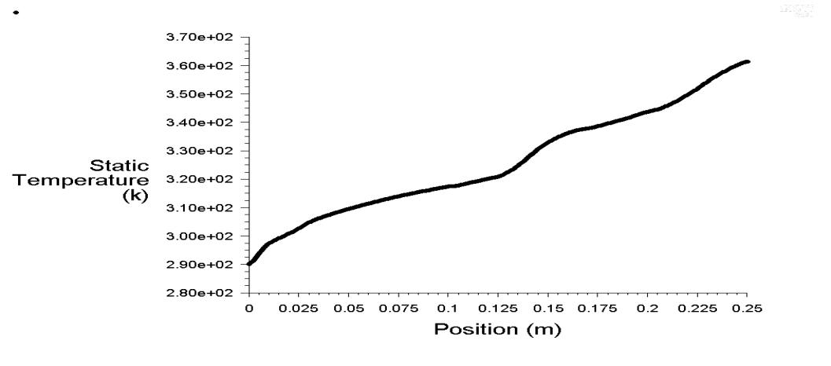

Fig 4.2 Temperature Variation along the pipe at v=0.053 m/s

**At v=0.707 m/s**

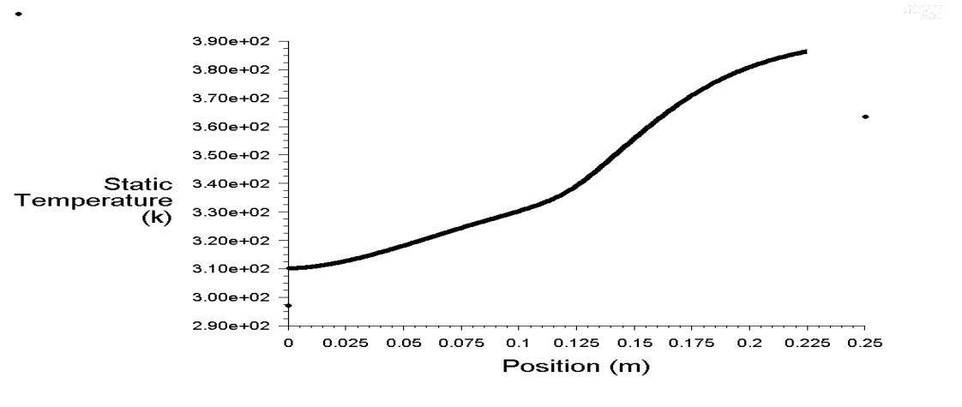

Fig 4.3 Temperature Variation along the pipe at v=0.707 m/s

**At v=0.8841 m/s**

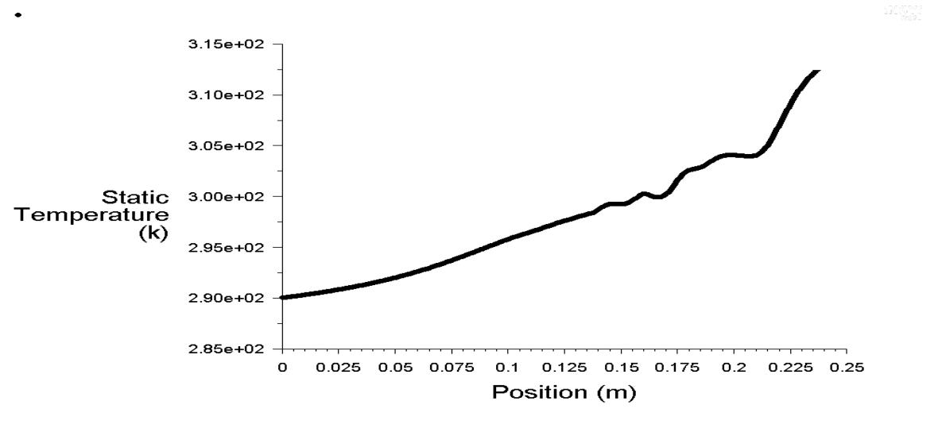

Fig 4.2 Temperature Variation along the pipe at v=0.8841 m/s

**4.4.2 Specific heat**

The variation of the Cp with length is calculated. An imaginary line is drawn parallel to the axis, along which the other thermal properties are calculated. A peak is observed at 304 ◦C. From graphs we can say that the spike in specific heat value shifts towards right as the velocity input of the fluid increases.

**For v = 0.053 m/s**

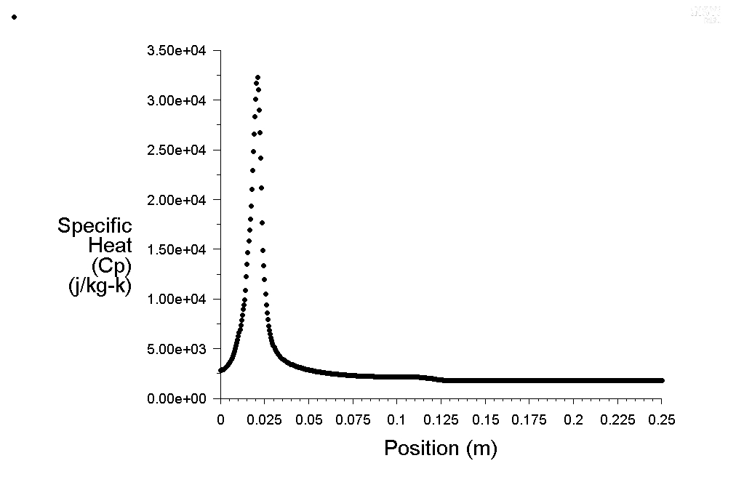

Fig 4.2 Specific Heat Variation along the pipe at v=0.053 m/s

**For v = 0.707 m/s**

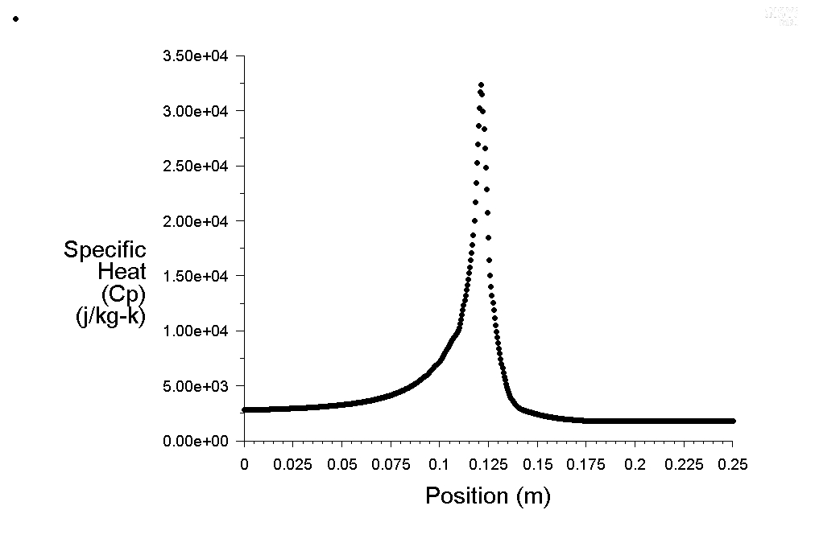 Fig 4.2 Specific Heat Variation along the pipe at v=0.707 m/s

**For v = 0.8841 m/s**

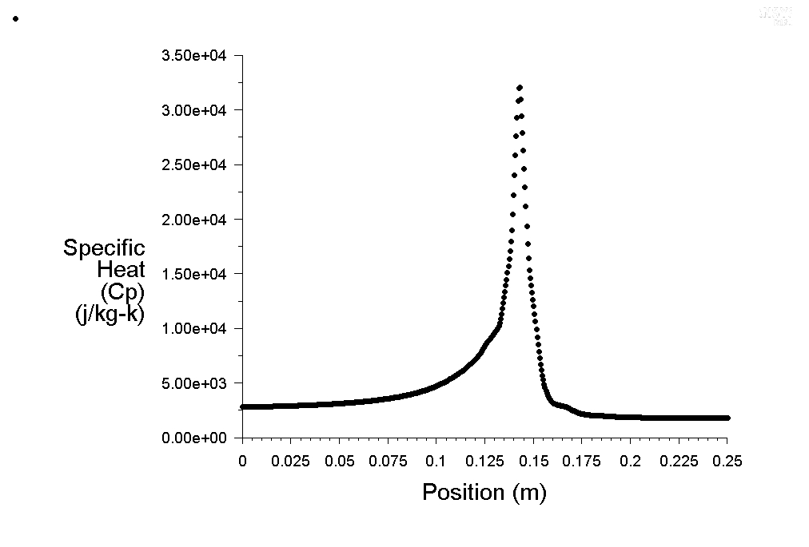Fig 4.2 Specific Heat Variation along the pipe at v=0.8841 m/s

**4.4.3 Specific heat variation keeping both the velocities variable**

Velocity of water = 0.042 m/s

Velocity of SCO2 = 0.053 m/s

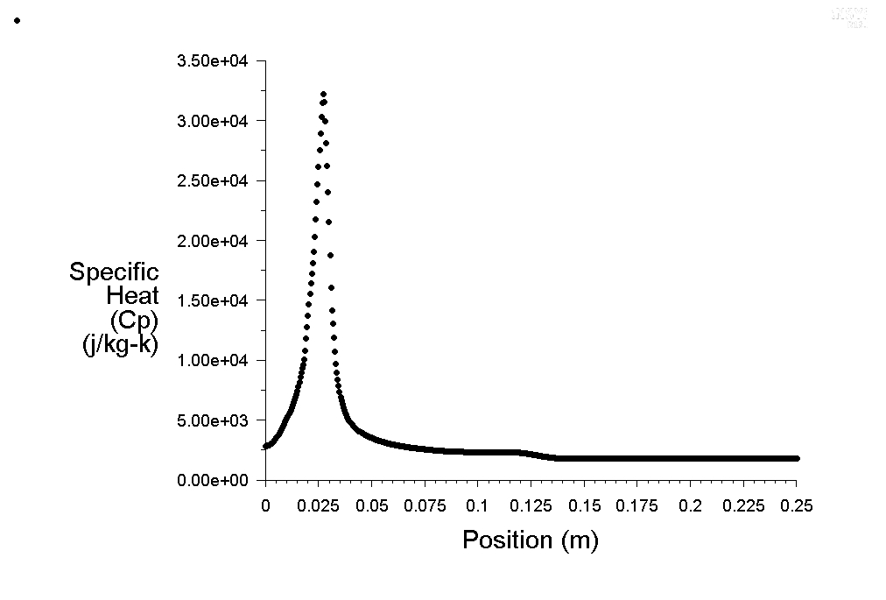

Fig 4.2 Specific Heat Variation along the pipe at variable velocities (1)

Velocity of water = 0.5053 m/s

Velocity of SCO2 = 0.7071 m/s

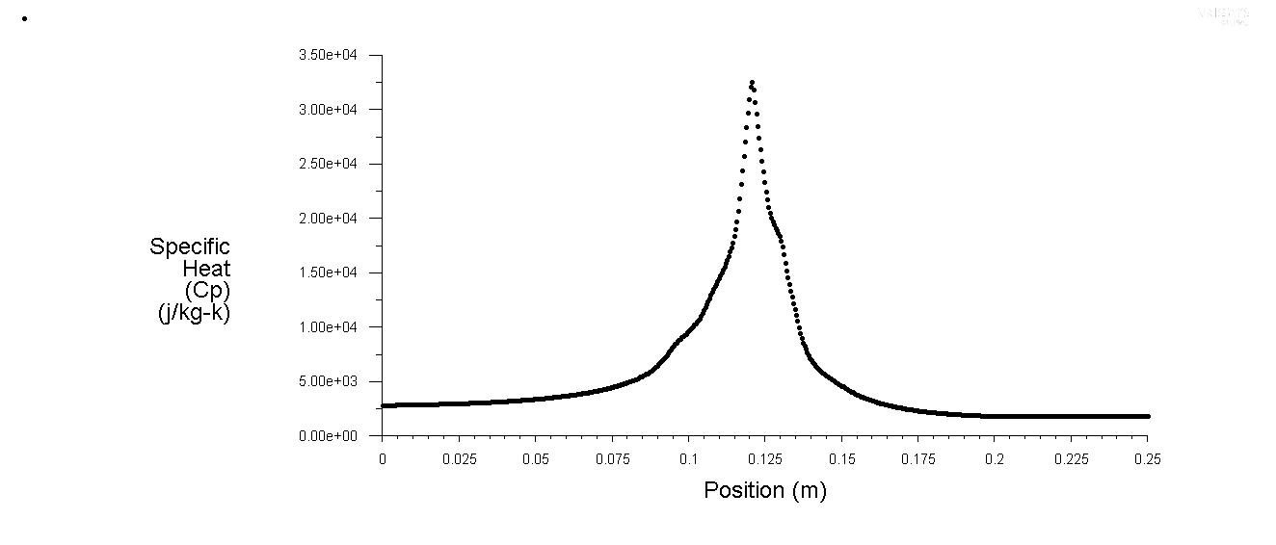

Fig 4.2 Specific Heat Variation along the pipe at variable velocities (2)

Velocity of water = 0.7071 m/s

Velocity of SCO2 = 0.8841 m/s

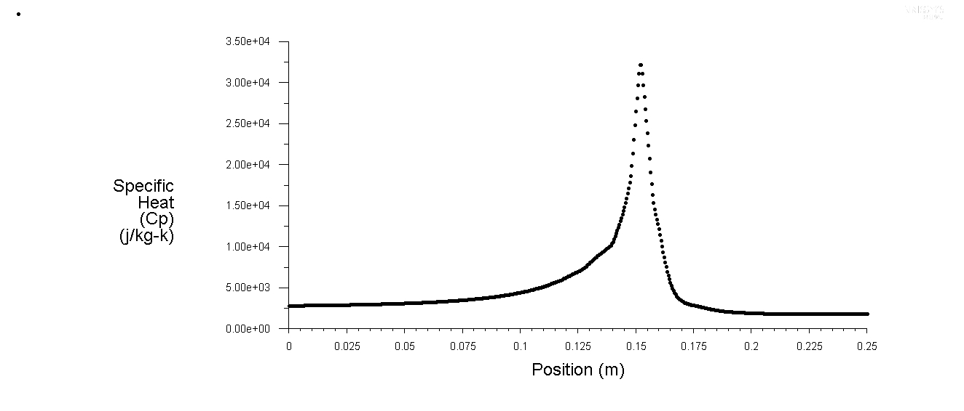

Fig 4.2 Specific Heat Variation along the pipe at variable velocities (3)

**4.4.4 Thermal conductivity Variation**

The thermal conductivity decreases with increasing temperature, but as the fluid reaches the super critical stage at 305 K, there is a slight increase in thermal conductivity value. after 308 K the value decreases gradually along the length.The unusual peak observed in conductivity is due to high specific heat observed at that point.

**For v = 0.053 m/s**

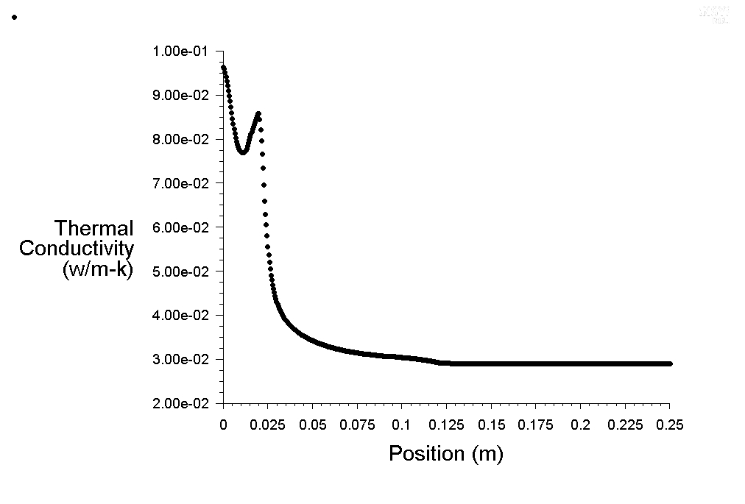

Fig 4.2 Thermal Conductivity Variation along the pipe at v=0.053 m/s

**For v=0.7071 m/s**

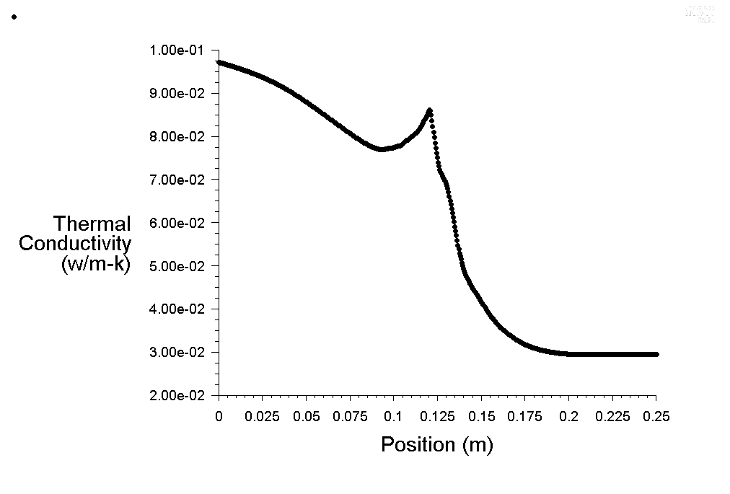

Fig 4.2 Thermal conductivity Variation of along the pipe at v=0.707 m/s

**For v = 0.8841 m/s**

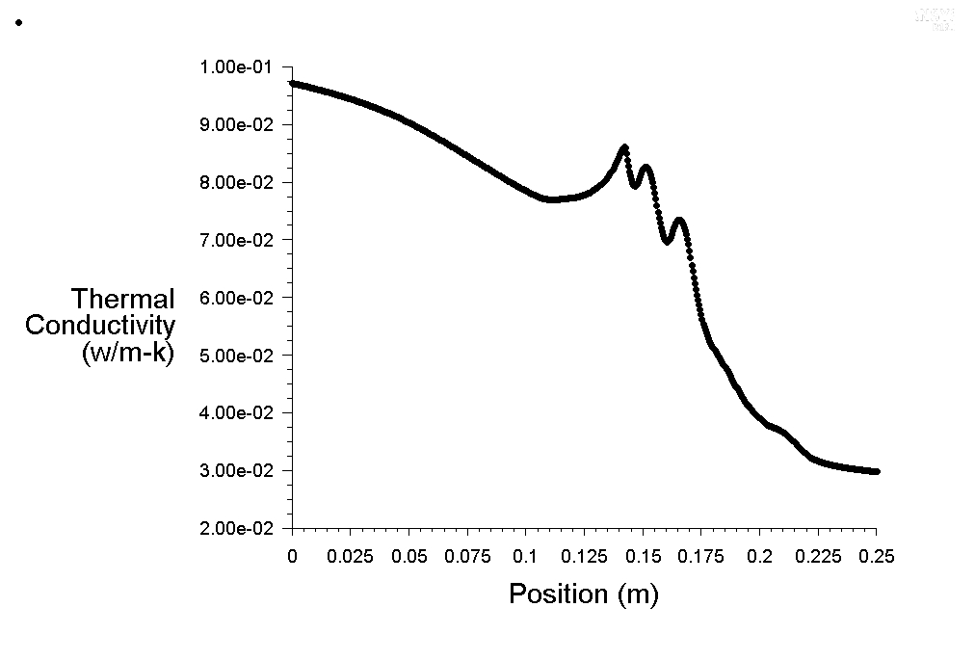

Fig 4.2 Thernal Conductivity Variation of along the pipe at v=0.8841 m/s

**4.4.5 Thermal conductivity variation taking different velocities respectively**

Velocity of water = 0.042 m/s

Velocity of water = 0.053 m/s

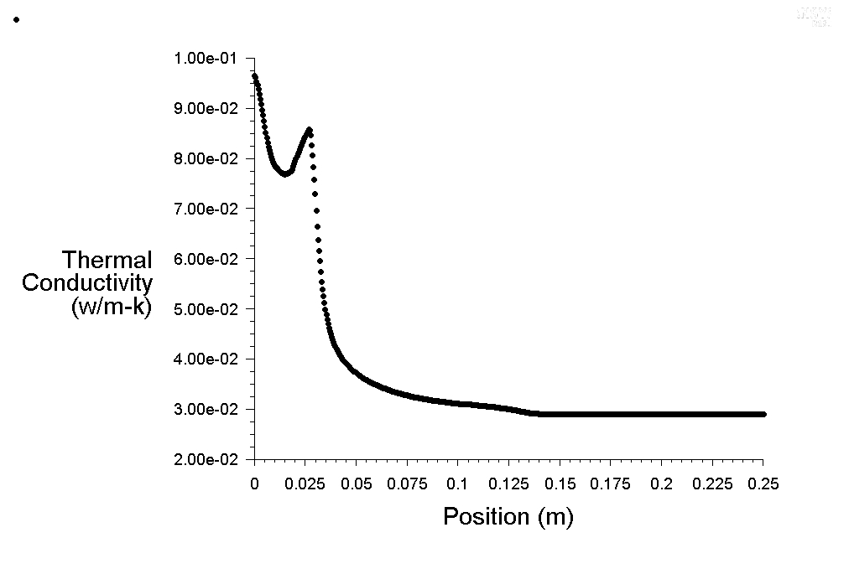

Fig 4.2 Thermal Conductivity Variation along the pipe at variable velocities (1)

Velocity of water = 0.5053 m/s

Velocity of SCO2 = 0.7071 m/s

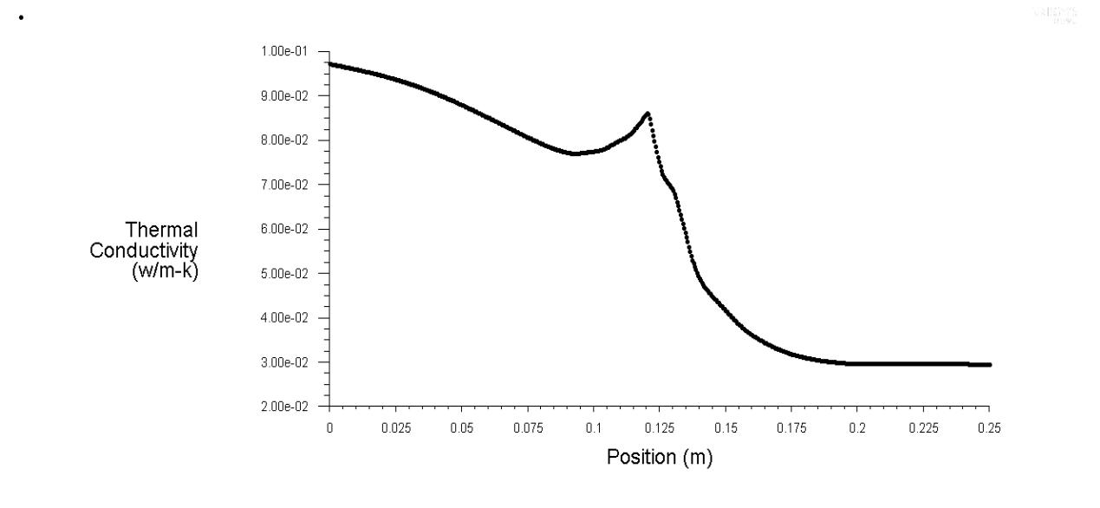

Fig 4.2 Thermal Conductivity Variation along the pipe at variable velocities (2)

Velocity of water = 0.7071 m/s  
velocity of SCO2 = 0.8841 m/s

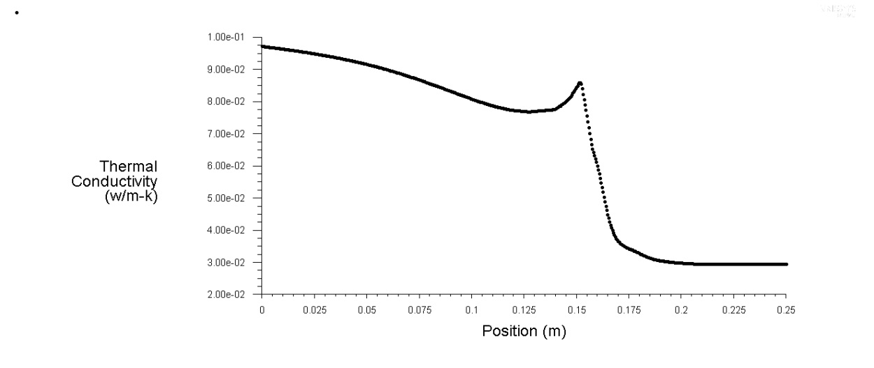

Fig 4.2 Thermal Conductivity Variation along the pipe at variable velocities (3)

**4.4.6 Temperature Contour**

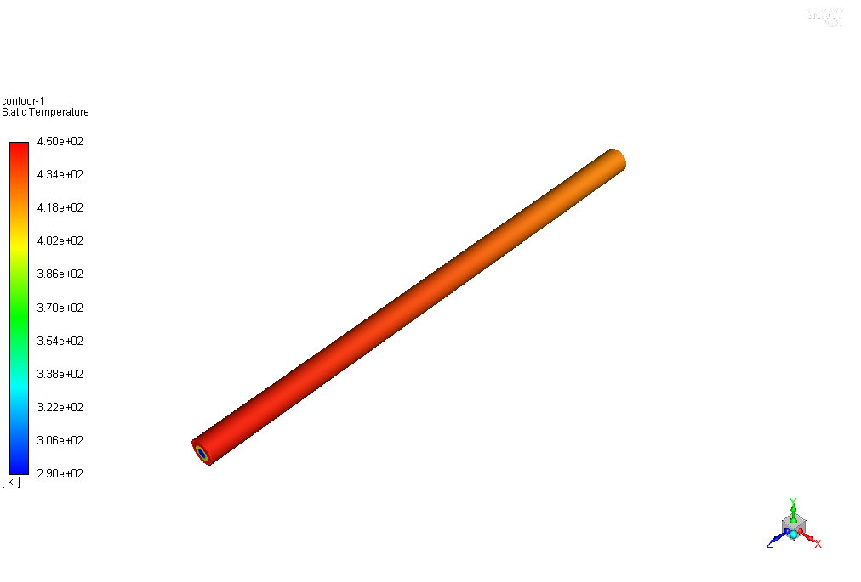

Fig 4.2 Temperature Contour of the Double Pipe

It can be seen that the temperature variation is less along the length when both the velocities of water and SCO2 are kept constant. It is because at the same velocity the heat transfer is less.

**4.4.7 Temperature Contour for variable velocities**

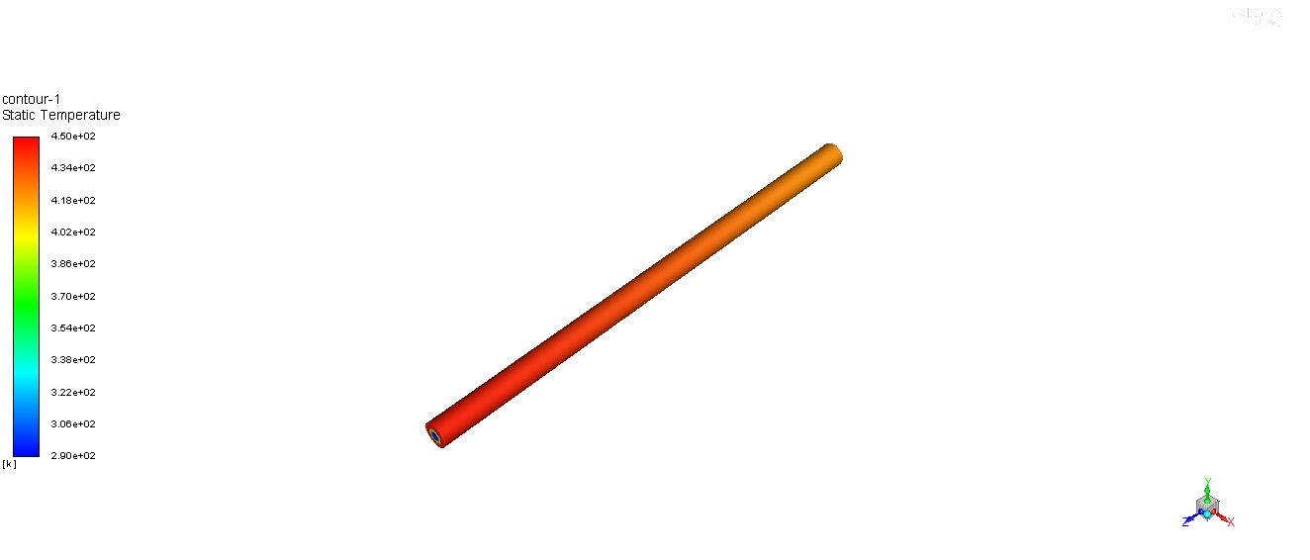

Fig 4.2 Temperature Contour for variable velocities of the Double Pipe

It can be seen that the temperature variation is more along the length when both the velocities of water and SCO2 are variable. It is because as the velocity of water is less, the rate of heat transfer is more.

**4.5 Formulae**



**4.6 Calculation table**

Comparison between two flow conditions:

|  |  |  |  |  |
| --- | --- | --- | --- | --- |
| Velocity | Values | Nu | h | Pressure drop (Pa) |
| V1 | 0.053 | 9.24 | 179.256 | 2.4 |
| V2 | 0.7073 | 8.43 | 163.542 | 2.3 |

**4.7 Discussion**

A pressure drop of 2.4 Mpa is observed across the carbon (inner) pipe.A pressure drop of 1.1 Mpa is observed across the water (outer) pipe. Lower velocities of water is suitable for efficient heat transfer between the pipes.We can also increase the heat transfer by increasing the diameter of the outer pipe.

**3D Analysis of a Double Pipe Heat Exchanger with Fins**

**5.1 Introduction**

A detailed 3D model of a double pipe is created.The length of the pipe is 250 mm.The inner and outer diameter are 5mm and 10 mm respectively. In this model, fins of 1mm are added to compare the Heat Transfer co-efficients and Pressure drop. SCO2 and water passes through the inner pipe and outer pipe respectively in counterflow direction.The boundary conditions provided are velocity and heat flux which are 0.53 m/s and 1000 W/m^2 respectively. SCO2 is used as working fluid. Carbon-dioxide behaves as a super critical fluid at a temperature of 304K and 8 MPa.

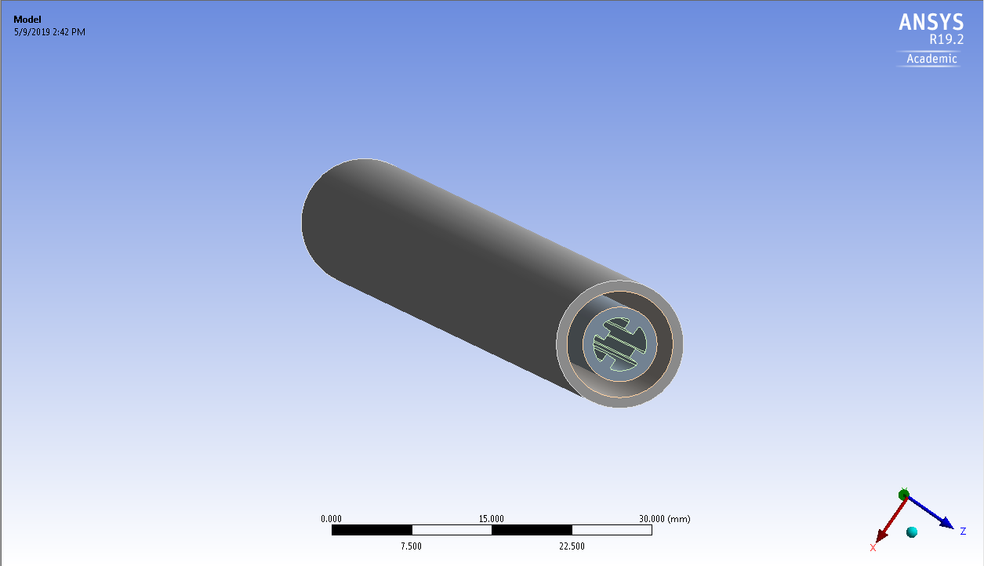

**5.2 Meshing**

The geometry is meshed in Fluent.The inlet and outlet faces are linked so equal meshing is obtained. All the edges and faces are quad meshed. The number of elements obtained after meshing is

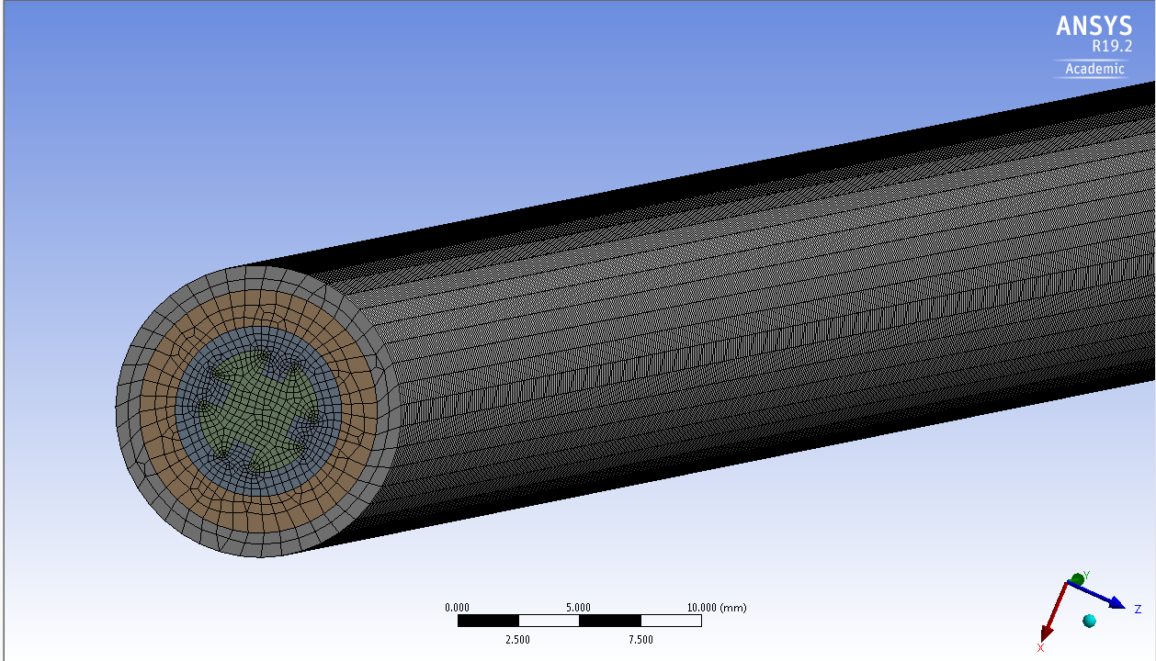

**5.3 Fluent Details**

The flow is steady, laminar and compressible.

3D geometry is created.

Meshing is finer near the wall.

Simple Solver is used.

Material Properties: Air (default)

Operating Pressure: 101325 Pa.

Wall constant Heat Flux: 100w/m2

Pressure-Velocity Coupling: SIMPLE

**5.4 Graphs**

**5.4.1 Temperature Variation**

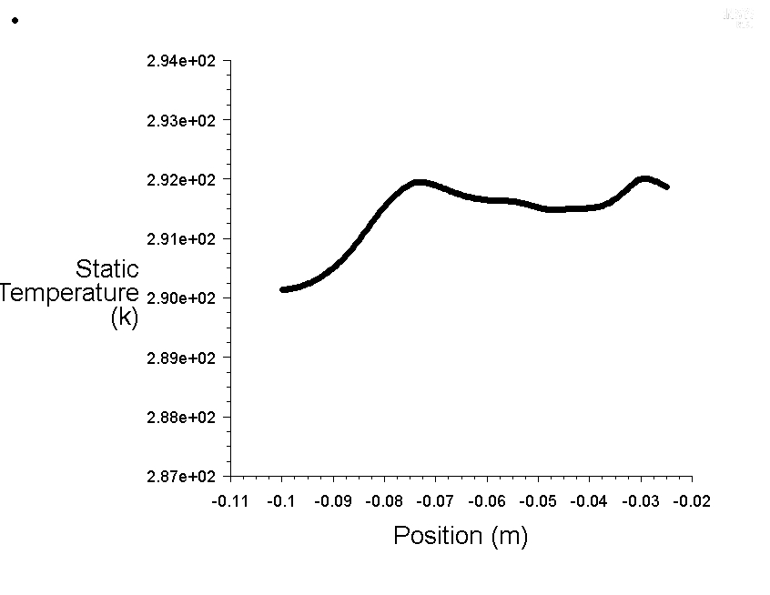

**5.4.2 Specific Heat Variation**

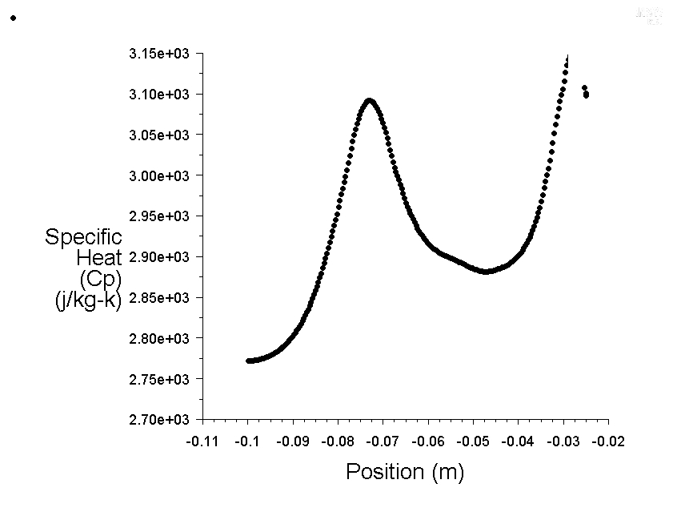

**Thermal Conductivity Variation**

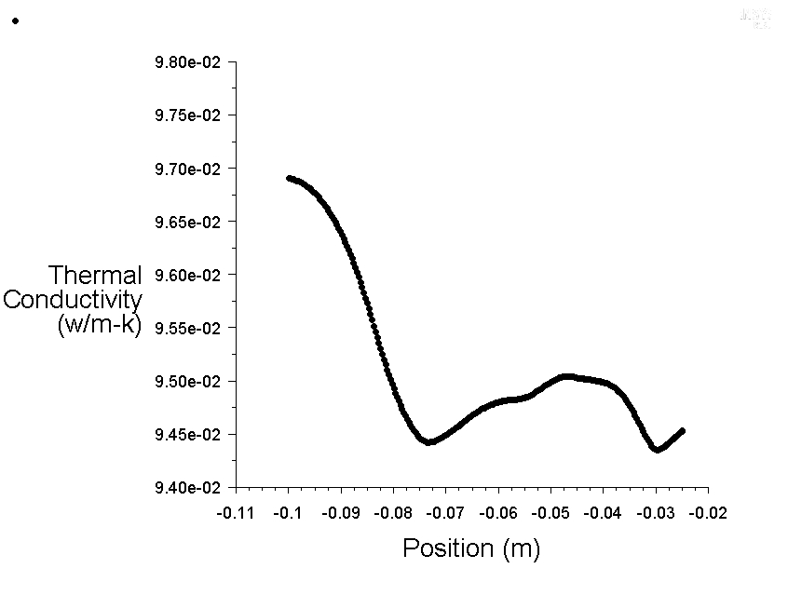

**Viscosity Variation**

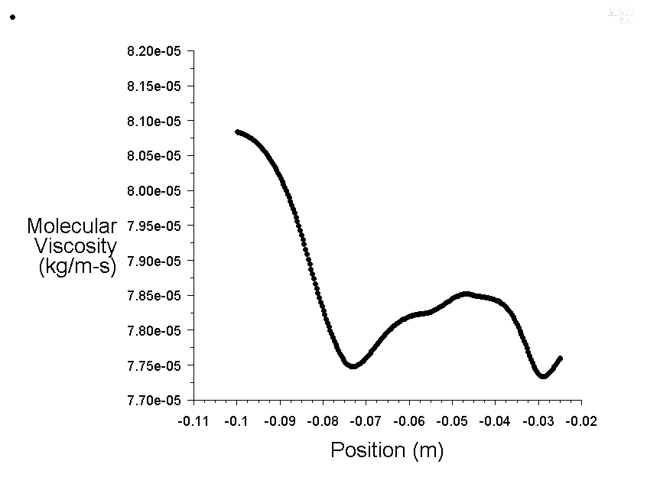

**5.4.5 Temperature Contour**

**Inlet**

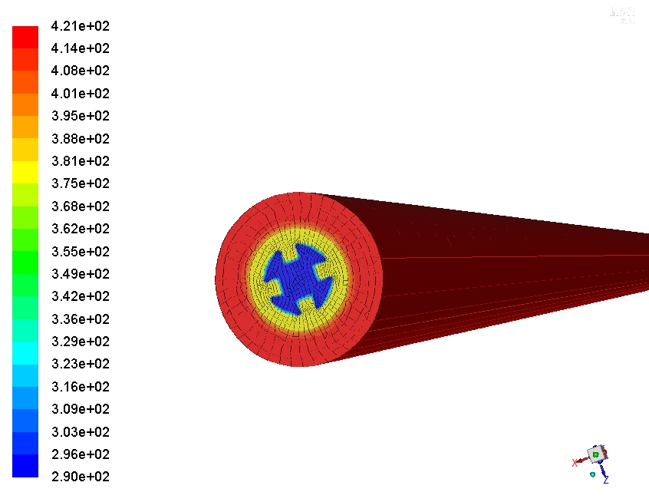

**Outlet**

